Name: MARIAM ALHASSAN BANDA .

Index Number:

Course: ARC 358: Rural/Urban Environments

**Programme 1: Construction details documentation**

Year: Architecture 3

Semester One: 2022 Academic Year

1. **Detail A- Foundation detail**

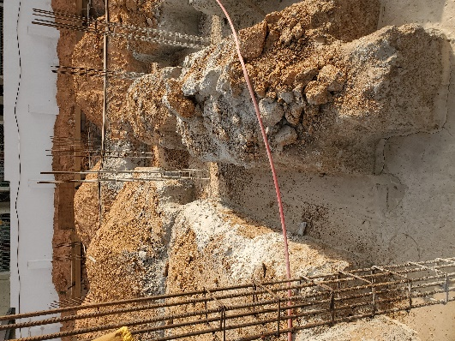



Photograph of foundation from site

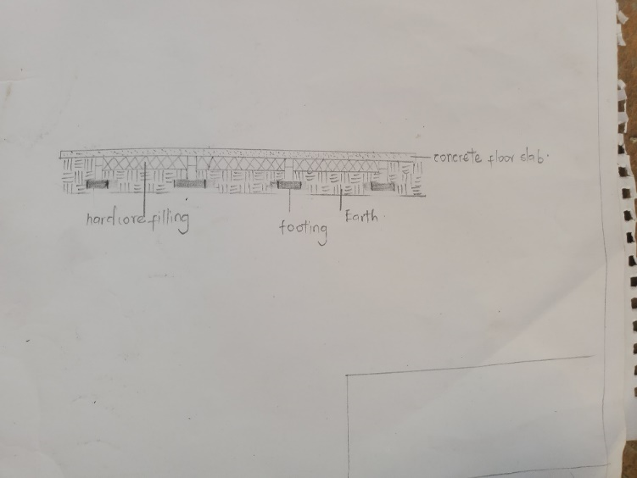

Sketch of foundation with dimensions

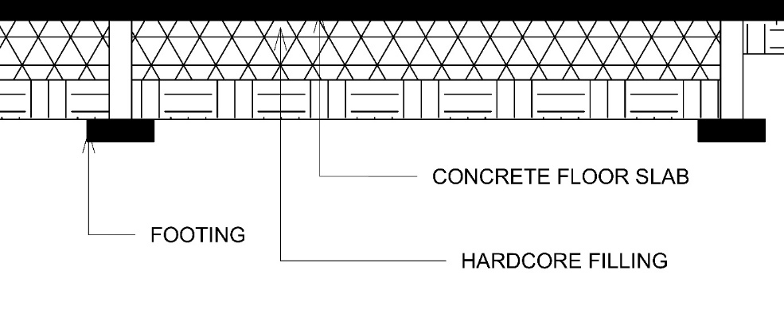

Drawing of foundation detail to 1:150. Drawing should be well labelled



1. **Detail B- Roof anchor detail**

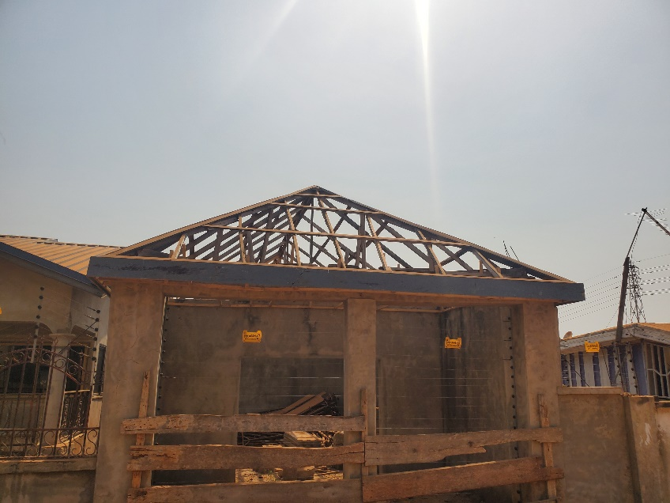

Photograph of how roof is anchored to the wall

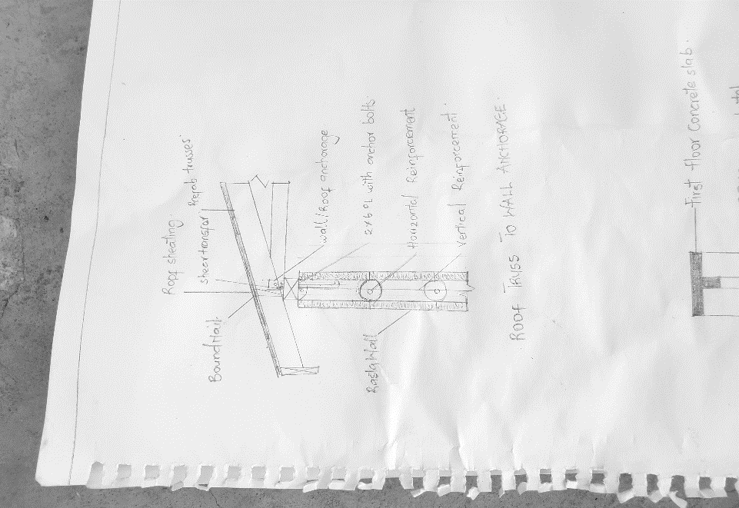

Sketch of how roof is anchored to the wall with dimensions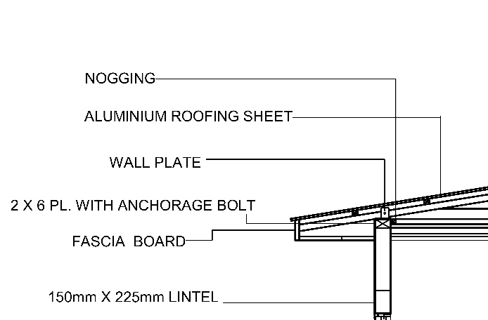

Labelled drawing of how roof is anchored to the wall with dimensions

1. **Detail C- Staircase details**

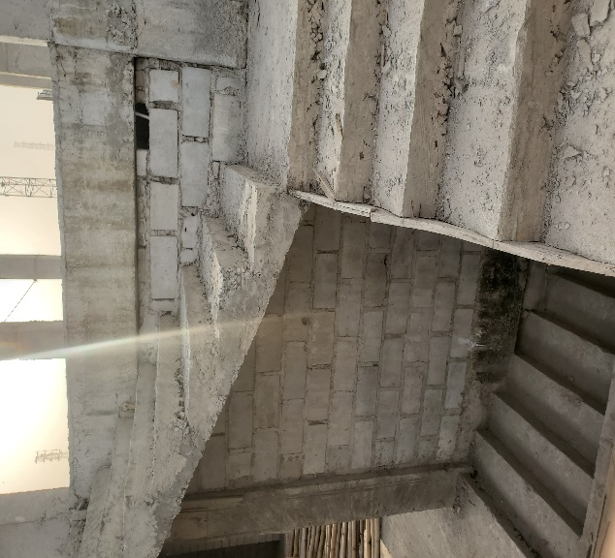

Photograph of staircase

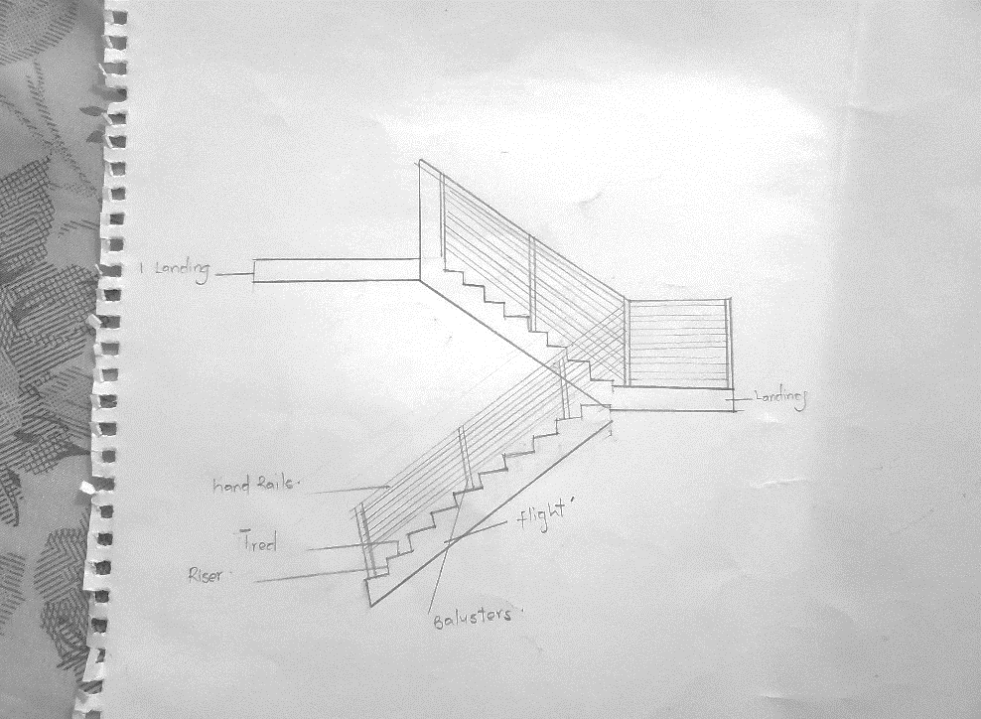

Sketch of staircase construction with dimensions

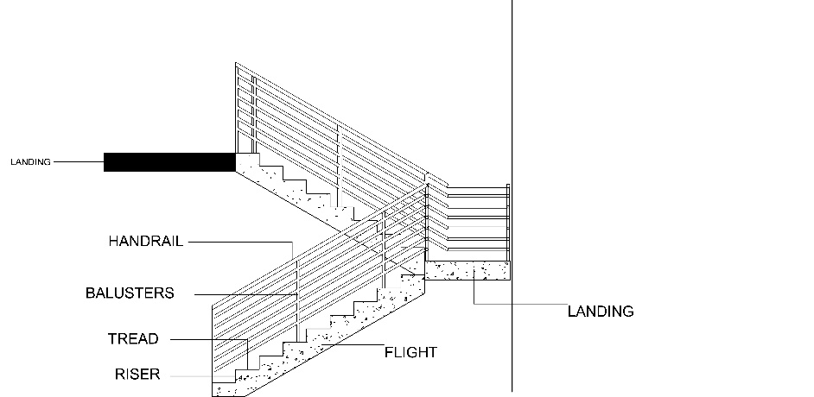

Labelled drawing of staircase with dimensions

1. **Detail D- Roof structure details**

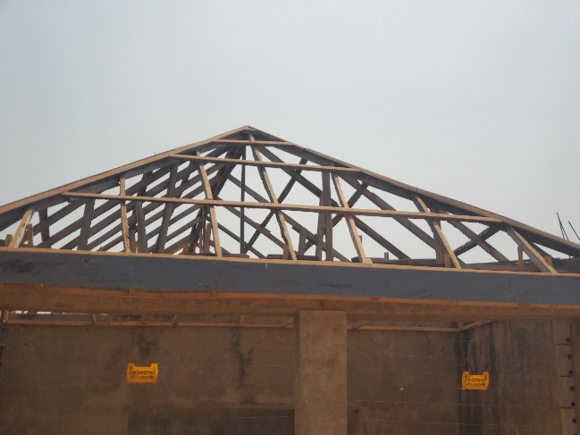

Photograph of roof structure

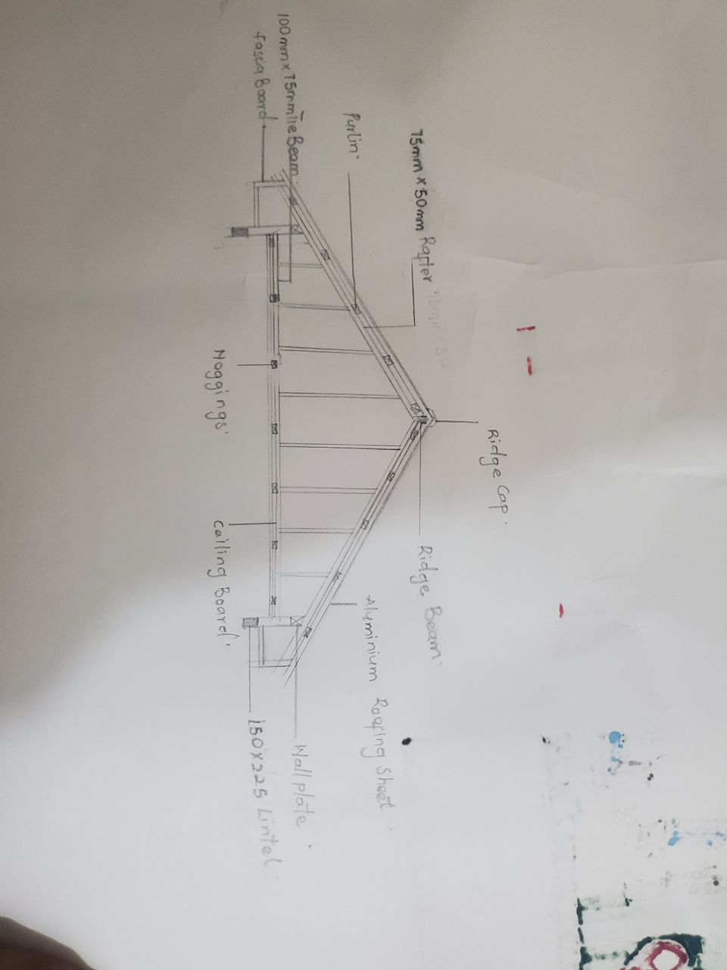

Sketch of roof structure with dimensions

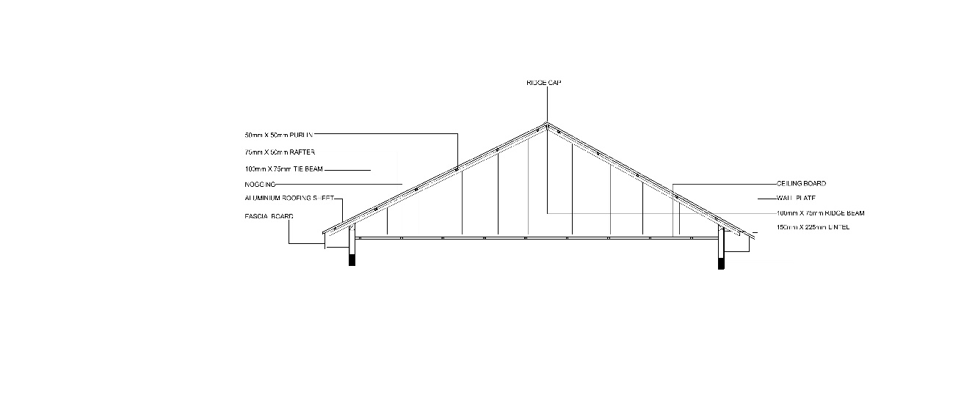

Labelled drawing of roof structure with dimensions

1. **Detail E- Window details**

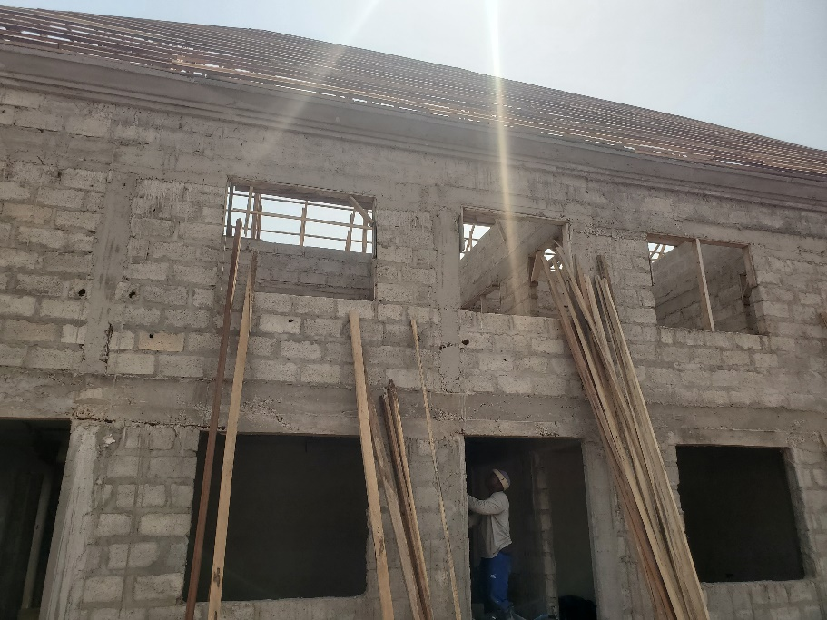

Photograph of window from site

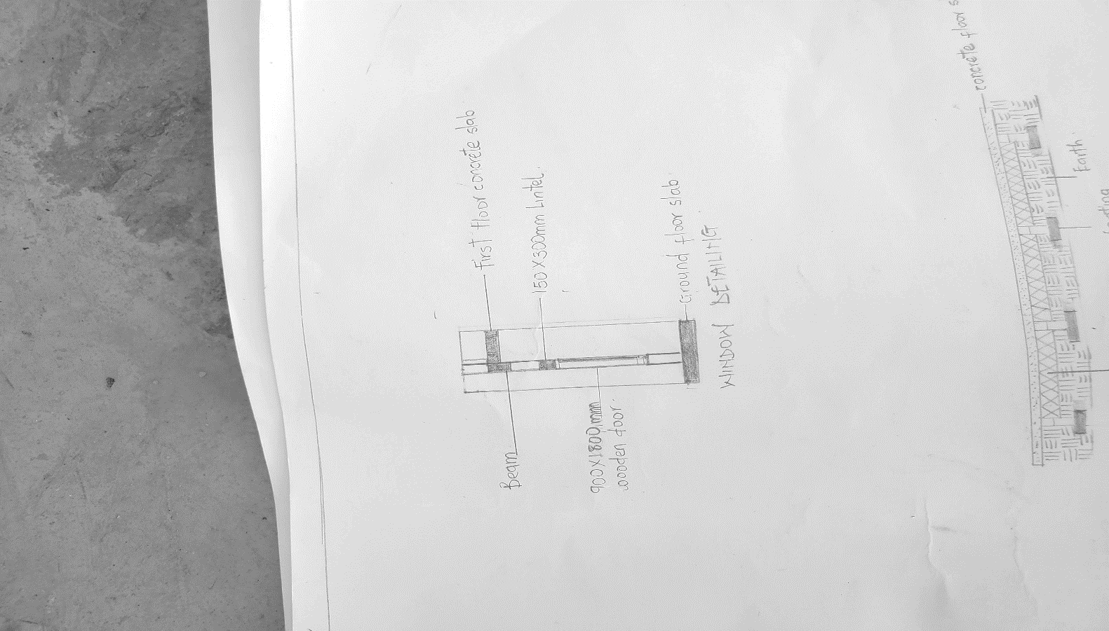

Sketch of window details from ground floor slab to first floor slab with dimensions 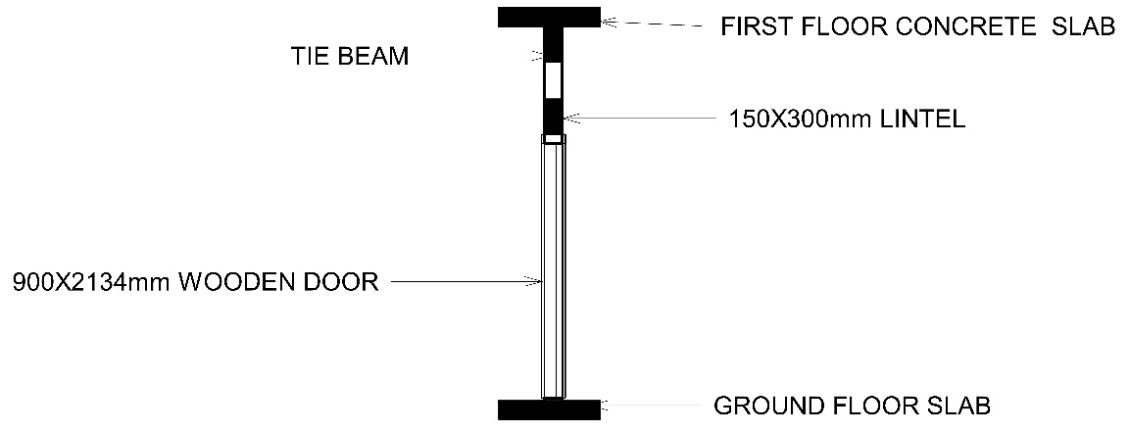

Labelled drawing of window details from ground floor slab to first floor slab with dimensions

**6.0 Detail F- Door details**

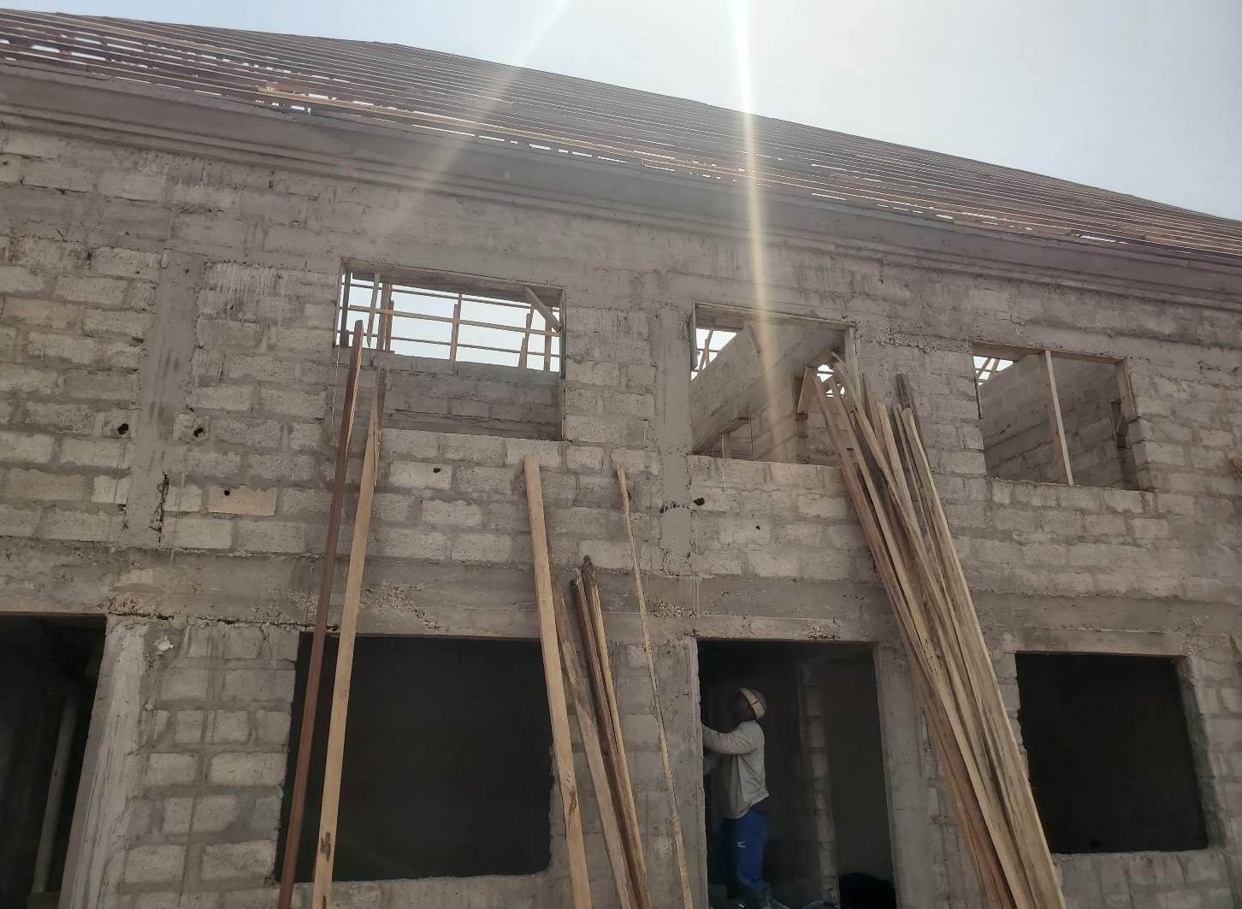

Photograph of door from site

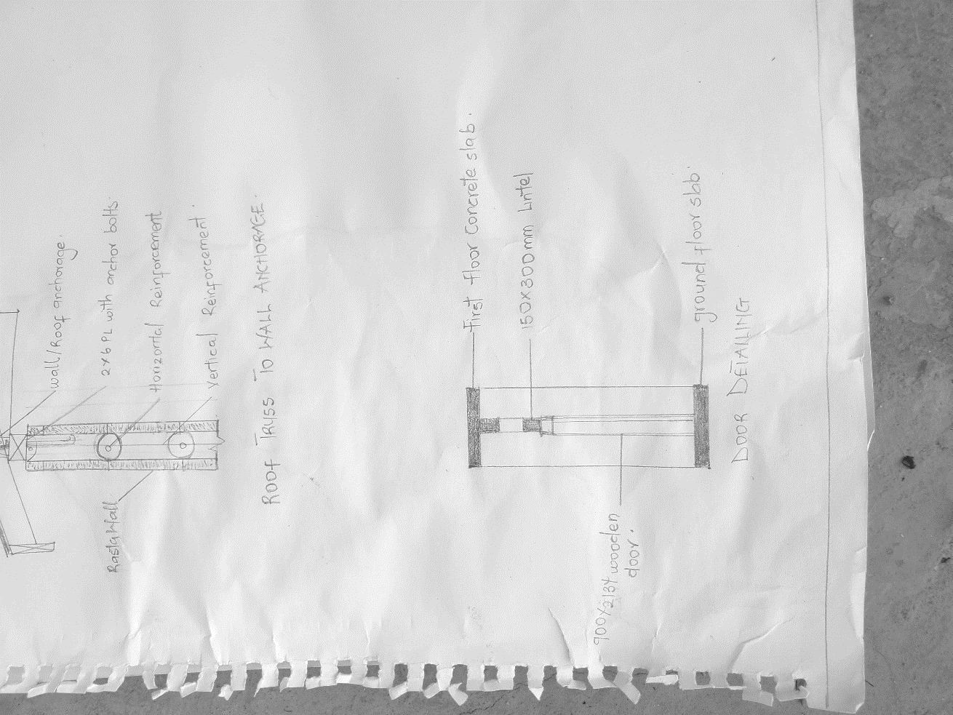

Sketch of door details from ground floor slab to first floor slab with dimensions

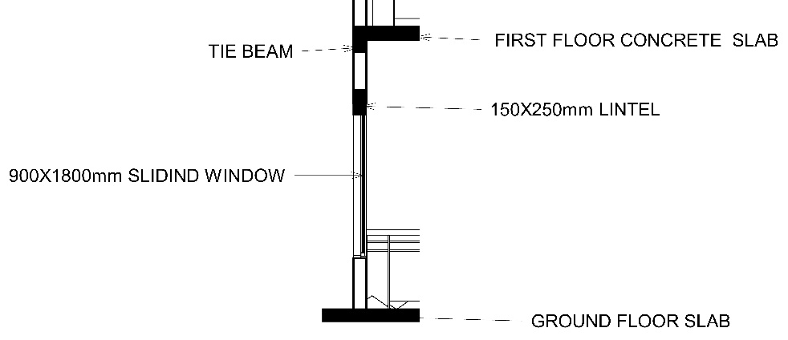

Labelled drawing of door details from ground floor slab to first floor slab with dimensions